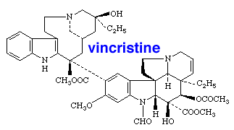

[www.chm.bris.ac.uk](http://www.chm.bris.ac.uk/webprojects2002/jjones/Content/vincristine.htm)